**Tips on communicating human rights effectively**

Rights areas:

* [Support for human rights systems and defenders](https://fra.europa.eu/en/taxonomy/term/989)

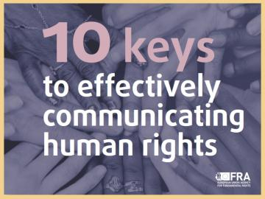

What does effective human rights communications really mean? And how should we do it? Participants at FRA’s recent workshop share their views.

**Publication**

[**10 keys to effectively communicating human rights**](https://fra.europa.eu/node/27626)

On 3 and 4 October, over 80 human rights communicators came to FRA to share their practices and strategies for effectively communicating rights.

FRA captured their thoughts in a [video](https://fra.europa.eu/en/video/2019/10-keys-effectively-communicating-human-rights) that builds on FRA's ‘[10 keys to effectively communicating human rights](https://fra.europa.eu/en/publication/2018/10-keys-effectively-communicating-human-rights)’.

Insights include Liba Beyer, Campaign Director of Human Rights Watch, warning: “We're trying to sell vegetables in a world of candy.”

And Flavia Kleiner, founder of Operation Libero, responding: “You need to be able to say your message in one picture and five words. That’s all you get.”

The video draws on discussions held over two days. Participants focused on how best to effectively communicate about human rights while engaging the ‘conflicted’ middle as well as new audiences.

Together they jointly strategised about which narratives communicators need to adopt to better communicate the message that human rights are for everyone.

Videos from the [various talks are also available online(link is external)](https://www.youtube.com/watch?v=exRS44C-fWU&list=PLZMjtrRo5niOxvn6irigB81ysLl9oqur7).